**PRACTICAL 5**

**AIM:** Write and test a program to update 10 student records into table into Excel file(Using TestNG).

**CODE:**

package p5;

import org.testng.annotations.BeforeClass;

import org.testng.annotations.Test;

import jxl.*;

import jxl.read.*;

import jxl.write.*;

import java.io.*;

public class countstuds {

@BeforeClass

public void f1()

{}

@Test

public void testImportexport1() throws Exception {

FileInputStream fi = new FileInputStream("D:\\st\\st\\excel data\\sampledata.xls");

Workbook w = Workbook.getWorkbook(fi);

Sheet s = w.getSheet(0);

String a[][] = new String[s.getRows()][s.getColumns()];

FileOutputStream fo = new FileOutputStream("D:\\st\\st\\excel data\\result.xls");

WritableWorkbook wwb = Workbook.createWorkbook(fo);

WritableSheet ws = wwb.createSheet("result1", 0);

for (int i = 0; i < s.getRows(); i++)

{

for (int j = 0; j < s.getColumns(); j++)

{

a[i][j]=s.getCell(j,i).getContents();

Label l2=new Label(j,i,a[i][j]);

ws.addCell(l2);

Label l1=new Label(6,0,"Results");

ws.addCell(l1);

}

}

for (int i = 1; i < s.getRows(); i++)

{

for (int j = 2; j < s.getColumns(); j++)

{

a[i][j]=s.getCell(j,i).getContents();

int x=Integer.parseInt(a[i][j]);

if(x>35)

{

Label l1=new Label(6,i,"Pass");

ws.addCell(l1);

}

else

{

Label l1= new Label(6,i,"Fail");

ws.addCell(l1);

break;

}

}

}

wwb.write();

wwb.close();

}

}

**INPUT FILE(sampledata.xsl):**

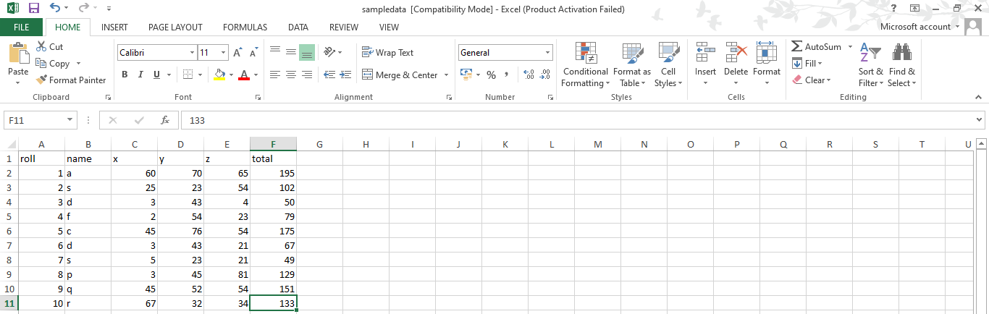

**OUTPUT FILE(result.xsl):**

